**Tanner Wale**

**SNHU**

**CYB-230**

**Project Two**

Configure Task Scheduler to **back-up** the old server. Provide a screenshot of the Task Scheduler summary screen.

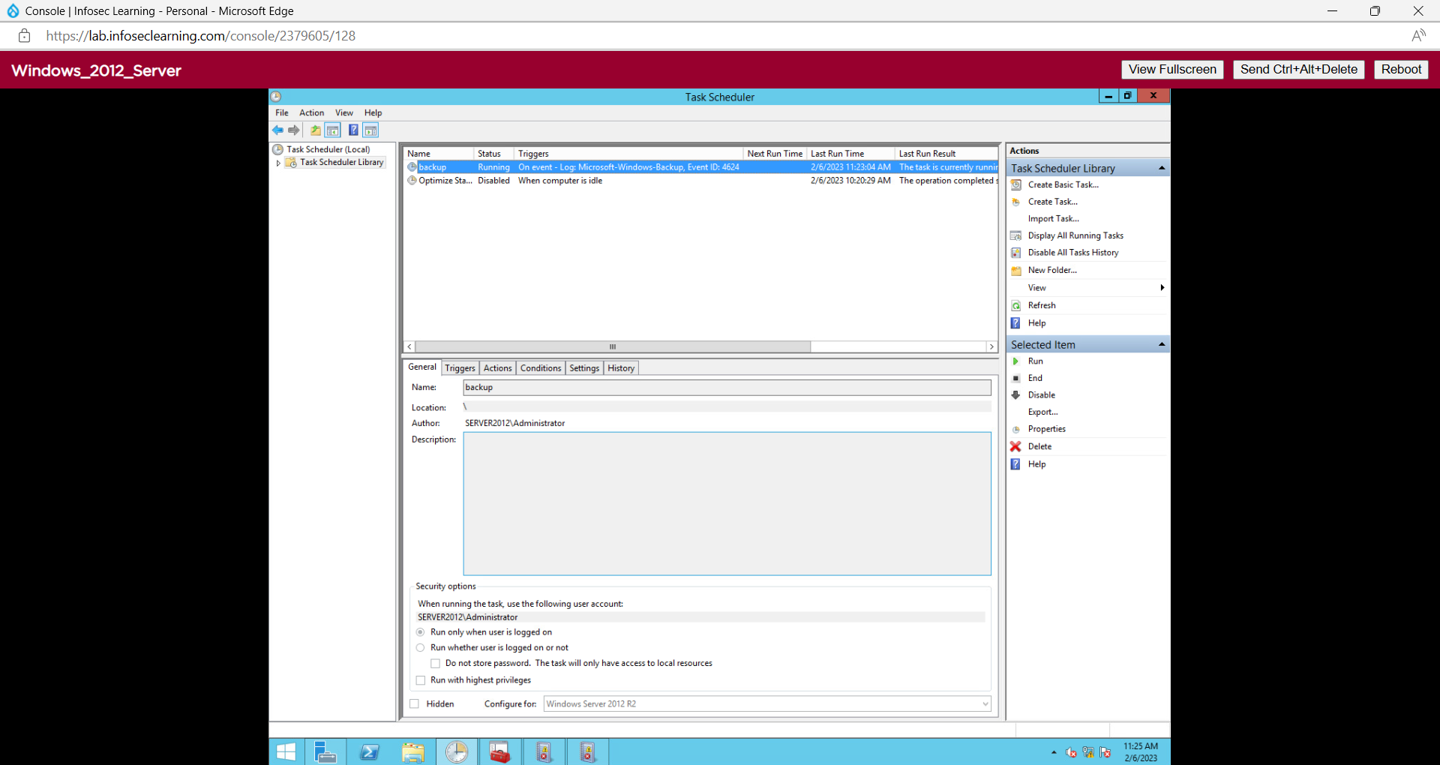

Configure a **trigger** for event ID 4624 in the Task Scheduler on the old server to meet the scenario requirements. Provide a screenshot of the Event Viewer custom view.

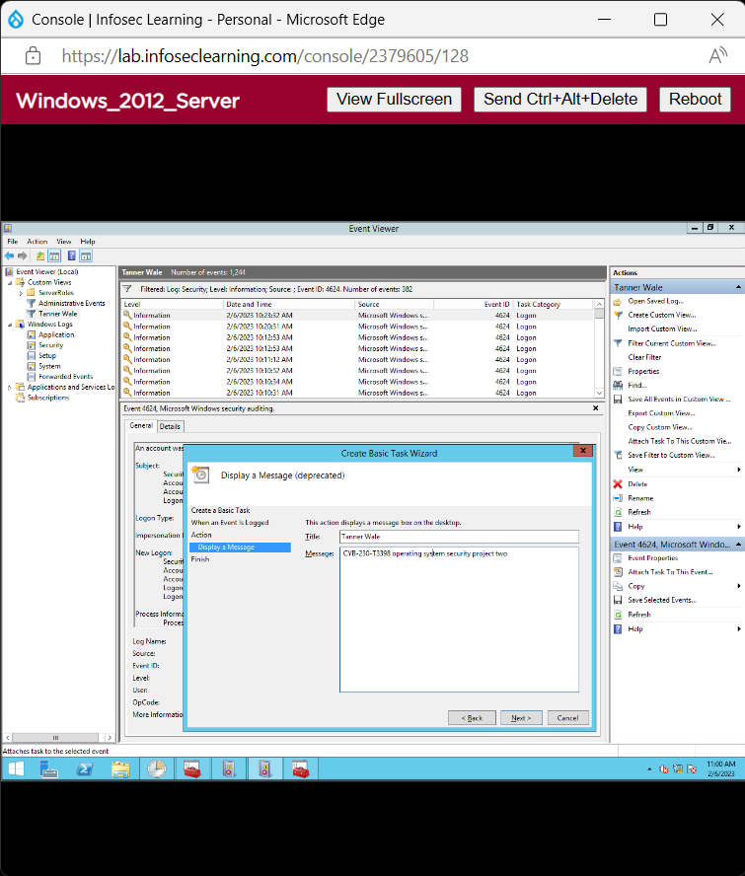

Create a **new organizational unit** (OU) to meet the scenario requirements. Provide a screenshot of the unit in the Active Directory tree. [CYB-230-03]

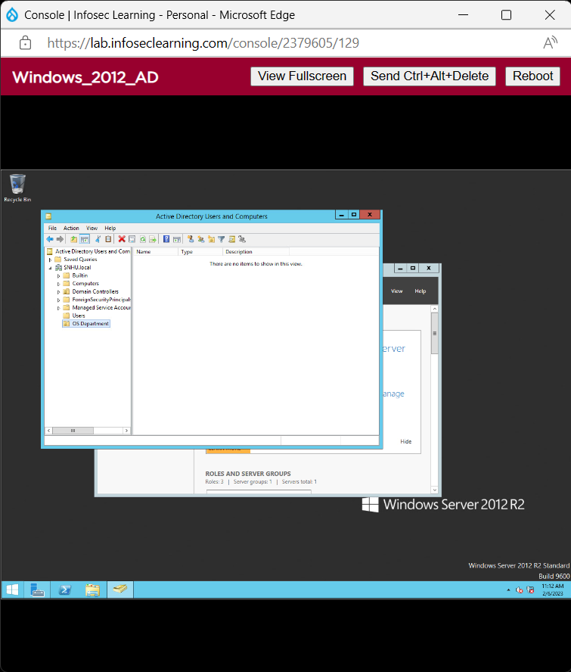

Create **new users** and add them to the new OU to meet the scenario requirements. Provide a screenshot of the users in the Active Directory tree. [CYB-230-03]

